Day 6 SQL bootcamp assignment

/*1. Categorize products by stock status

(Display product_name, a new column stock_status whose values are based on below condition

units_in_stock = 0 is 'Out of Stock'

units_in_stock < 20 is 'Low Stock')*/

select product_name,

case when units_in_stock =0 then 'out of stock'

when units_in_stock <20 then 'Low Stock'

else 'Available' end

as Stock_status

from products;

/* Q2.Find All Products in Beverages Category

(Subquery, Display product_name,unitprice)*/

select product_name, unit_price

from products

where category_id= (

select category_id from categories where category_name = 'Beverages'

);

/*Q3. Find Orders by Employee with Most Sales

(Display order_id, order_date, freight, employee_id.

Employee with Most Sales=Get the total no.of of orders for each employee then order by DESC and limit 1. Use Subquery)*/

select order_id, order_date, freight, employee_id

from orders where employee_id=(

select employee_id from orders

group by employee_id order by count(*) desc limit 1 )

/*Q4. Find orders where for country!= ‘USA’ with freight costs higher than any order from USA. (Subquery, Try with ANY, ALL operators)*/

select order_id, freight from orders

where ship_country !='USA' and freight > ALL (

select freight from orders

where ship_country='USA'

)

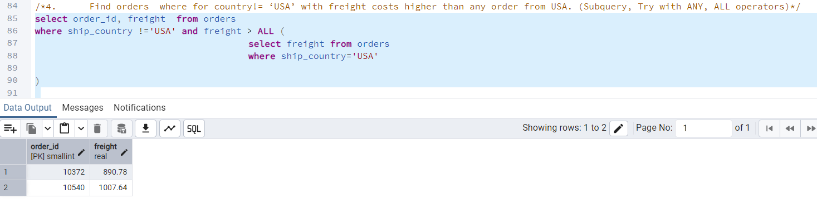

select order_id, freight, ship_country from orders

where ship_country !='USA' and freight > ANY (

select freight from orders

where ship_country='USA'

)

